**Answer the following questions considering the support documents and** [**https://netbeans.org/kb/docs/websvc/intro-ws.html**](https://netbeans.org/kb/docs/websvc/intro-ws.html)

**What are web services?**

Web Services transfer data using many Internet protocols, but must employ http ( Key communication protocol of the World Wide Web)

Can perform any task, it encapsulates a task; when the application passes data or instructions to it, the service processes that information and returns something to the application.

**What are the main characteristics of web services that distinguish them from other computer models?**

1. They are programmable – they can encapsulate a task, service processes informtion and returns something to the application
2. Based on XML and XML based SOAP are technologies that communicate with other applications

**c) What are the key web services technologies? Show web service interaction between them.**

**XML(Extensible Markup Language) :** Facilitate data exchange

**SOAP(Simple Object Access Protocol):** Common standards to deliver Web Services

Enable transfer data between systems distributed over a network

**WSDL ( Web Services Description Language) :** Defines the kinds of messages a Web Service can send and receive, as well as specifying the data a calling application must provide for the Web Service to perfom its task

**UDDI( Universal Description, Discovery and Integration):** Allows developers to publish an locate Web Services on the internet.

**What means publishing and consuming a web service?**

It means that when all of the technologies are package together, it is launched on internet

**What are the two main categories of web services?**

**REST :** Representational State Transfer, a new way to create and communicate with web services, resources have URIs and manipulated through http header operations

**SOAP:** Web Service interfaces are exposed through WSDL documents (XML type), which have URLs, message exchange is in SOAP, another type of XML document

**What are REST Web services? What are the four HTTP methods that can be used in REST?**

Collections of web resources identified by URIs. The resources are manipulated by the actions of an specificed http header.

GET, PUT, POST, DELETE

**What is JAX-RS? What is Jersey?**

Stands for JAVA API for RESTful Web Services, is a Java based programming language API and specification to provide support for created RESTful Web Services.

Jersey: Framework that provides it’s own API that extend the JAX-RS toolkit with additional features and utilities to further simplify RESTful service and client development

**What is WADL? How can you visualize it? Show an example.**

Web Application Description Language is a machine-readable XML description of HTTP-based web services.

It models the resources provided by a service and the relationships between them.

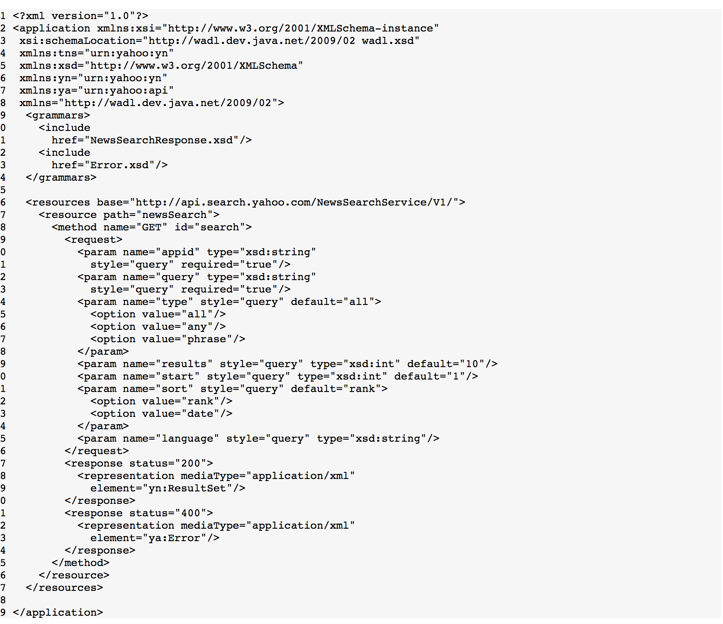

**What is SOAP?**

In this case, JAVA creates a WSDL based on the Java code in the web service. It is exposed on the net. Messages are exchanged in SOAP format. Suitable for heavyweight applications complicated operations and for applications requiring sophisticated security, reliability.

**What are the three main SOAP components?**

WSDL, UDDI (XML standard for describing, publishing and finding web services), XML-RPC ( XML based protocol for exchanging information between computers)

Three main components: Envelope, header and body.

**What is WSDL?**

XML based language for describing web services and how to access them

Stands for Web Servies Description Language

Protocol for information exchanged in decentralized and distributed environments

**How can you visualize WSDL? Show an example.**

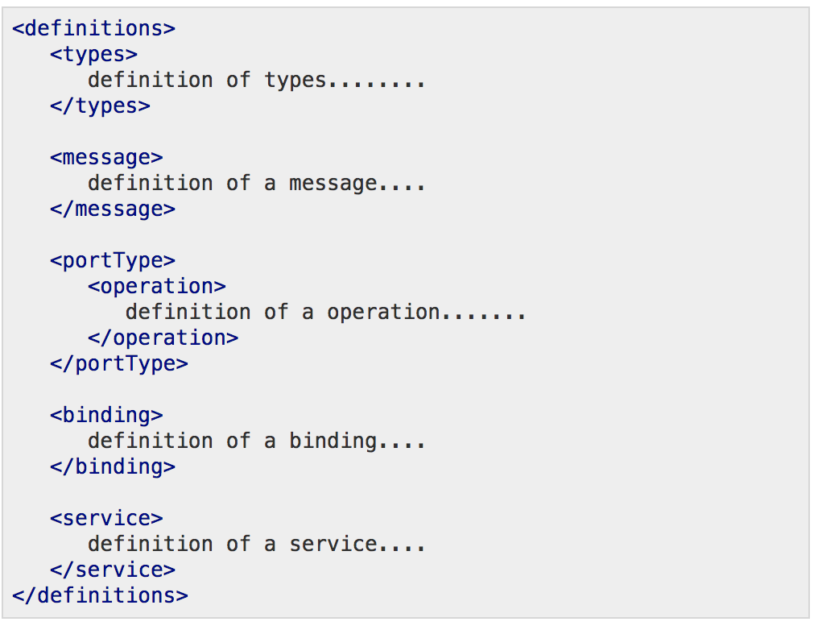

**What is JAX-WS?**

Technology for building web services and clients that communicate using XML.

Allows developers to write message-oriented as well as Remote Procedure Call-oriented web services.